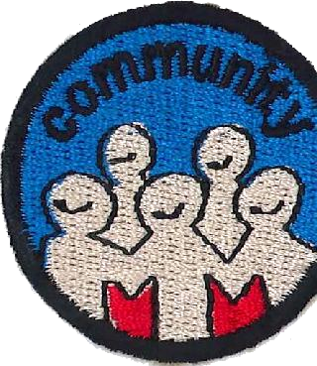


Term Two : Weeks Six & Seven My Community Community

Aims:
The purpose of this two week module is to learn about the community in which you live and what makes it different and unique.

As all communities are different, the following suggestions for these two sessions give you the leader, some ideas on topics that could be covered; this then gives you the opportunity to choose activities for the two weeks that fit your particular community.

Below are some suggestions:

Community Facilities:

- Public Library – who owns and runs the town library? Can you organise a visit?
- Does your City or town have a theme eg Auckland - City of Sails, Otorohanga – Kiwiana, Napier – Art Deco, Dunedin – Edinburgh of the South, Christchurch – Garden City? If so, check out the reasons for this theme.
- Tourist attractions and activities – what is available for tourists in your area? Check these out. Play “tourists” for one of your sessions.
- War Memorials – where are these and what memories do they hold for your community?
- Churches – look at the different Churches/Religions that are available in your community.
- What Service groups / Organisations are available ie Lions, Rotary etc. What do they do?
- Does your town have a swimming pool – who owns it / looks after it

How is your town governed?
- Does your community have its own City/District Council? If so, how does it work? Does it have a Logo/Crest?
- Visit the Council Chambers and sit in the Mayor’s seat.
- Visit the Mayor.
- Attend a naturalisation ceremony.
- Do you have a Member of Parliament you could visit?
- Do you have a Service Centre – what is its role?

Other places of interest:
Arrange for the girls to visit other places of interest in your community, places that they would not usually get the opportunity to visit - ideas here are:
- Historic buildings check out www.historicplaces.org.nz
- Visit the local Police Station, Fire Station, St John Ambulance base
- Local factories or businesses
- Colonial Heritage – check out the local Museums, Early Settlers

Foot Rally:
This is where you write a set of questions that are relevant to your area, and then the girls go off in groups to find the answers to those questions. This is a really good way for the girls to learn some of the history of their area and to familiarise themselves with the layout of your town or community.

SetUp:
The SetUp will depend on your activities for the evening.
If you are going out, ensure that you have taken the roll before departing from the usual meeting place, so that you know exactly how many girls you have. Check the number on your return to base.

Devotions:
Choose devotions that are relevant to the options you have chosen.

Notices:
Ensure that you prepare notices for the girls to take home with all the details for the two week module ie where to meet if meeting away from your usual base, time for girls to be dropped off and picked up etc.

